HILLY FIELDS FOOTBALL CLUB
SEASON 2: 1968-69
FIRST TEAM:
IMPERIAL LEAGUE:
P W D L F A Pts Pos
Division 2 16 9 2 5 62 30 20 3rd
Challenge Cup 2 1 0 1 7 10
Secondary Cup 3 2 0 1 7 9
Friendly 1 0 0 1 5 7
TOTAL 22 12 2 8 81 56

Apps Gls Apps Gls
Jim Blanchett 4 0 Dave Leggett 17 17
Bill Burke 1 0 Ken Longland 12 1
Phil Clover 9 4 Robin Mahoney 11 5
Ron Clover 3 0 Tim Nugent 1 0
Ron Davis 11 4 Ian Parsons 19 3
Len Franklin 20 16 Derek Pollard 1 0
Larry Garnham 16 1 Tom Pollard 13 4
Chris Green 7 3 Frank Ryan 19 1
Ray Griffin 15 0 Malcolm Smith 1 0
John Harding 19 0 Jim Stamp 2 0
Bobby Head 22 20 OG 1
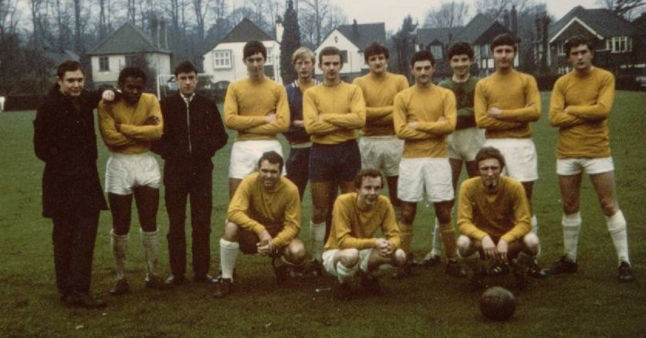
Bill Irwin 21 1
L-R Back:Phil Clover, Robin Mahoney, Ron Davis, Frank Ryan, Larry Garnham, Ian Parsons, Bobby Head, Billy Irwin, John Harding, Tom Pollard, Len Franklin.
L-R Front: Ken Longland, Ray Griffin, Dave Leggett.

